**Sequences Practice Problems**

1] Use Random function ((RANDOM)) to get single digit.

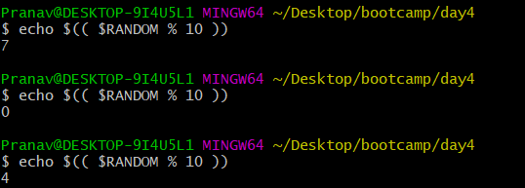

2]Use Random to get Dice Number between 1 to 6